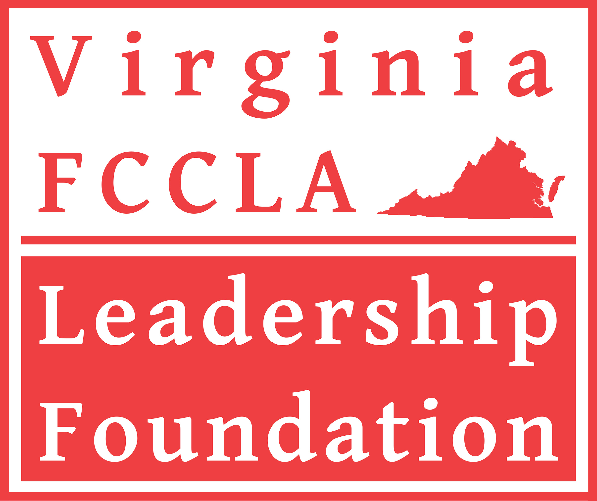

Virginia FCCLA Leadership Foundation
Deborah L. Will Scholarship

Purpose of Scholarship
Thank you for your interest in the Virginia FCCLA Leadership Foundation, Inc. (“FCCLA Foundation”) Deborah L. Will Scholarship. This is a competitive scholarship offered to encourage Virginia students to pursue careers as Family and Consumer Sciences (FCS) teachers and FCCLA advisers. One $1,000 scholarship will be considered for qualifying applicants.
Overview

The FCCLA Foundation was created to ensure the continuation of inspired youth leadership by supporting the growth and progress of the Virginia Association of Family, Career and Community Leaders of America. (www.virginiafccla.org).

As part of its mission, the Virginia FCCLA Leadership Foundation annually awards scholarships to college students enrolled in a Family and Consumer Sciences and/or related program of study who plan to enter FCS education at the middle or secondary level.
FCCLA Foundation scholarships are paid directly to the college/institution of choice and payment will be made in time to be applied to 2nd semester tuition during the scholarship year.
In making its selection, the FCCLA Foundation scholarship committee does not discriminate on the basis of race, color, religion, national origin, sex, or disability.
Criteria
The applicant must demonstrate a desire to pursue a career in Family & Consumer Sciences Education and become an FCCLA adviser.
The applicant must be a junior or senior college student, a first-year full-time graduate student, or a career switcher enrolled in good standing in a Virginia-based college or university. Juniors may apply and then would be allowed to apply again during the senior year; likewise, seniors may apply and then apply again the next year as a graduate student. Career switchers may apply consecutive years as long as enrolled.
The applicant must be a Virginia in-state student.
Application process
Applications are reviewed and evaluated for completeness and strengths of applicant with emphasis on FCCLA student organization participation at local, state, and national levels, and future career plans tied to becoming an FCS teacher and FCCLA adviser. The winner will be introduced at the Virginia FCCLA State Leadership and Recognition Conference in the spring. Announcement of the winner(s) will be posted on the FCCLA website with a photo, if available.
It is the responsibility of the applicant to complete all parts of the application package. Pages 1 and 2 are to be completed by the student. Forms are Word documents and may be downloaded, saved with your file name, and completed on your computer and printed for signatures or signatures may be scanned in.
No late applications will be accepted.
Checklist (please assemble application in this order):
___ Pages 1-2 completed by the applicant
___ Official transcript (if the official transcript cannot be submitted by the deadline, then please send an unofficial transcript so that the application will not be incomplete, with the official transcript to follow as soon as possible)
___ Two letters of recommendation*
*Two letters of recommendation from unrelated individuals:
Potential individuals include: high school FCCLA adviser, school official (e.g., professor, coach, school counselor, or administrator), or an individual who can speak to your involvement in FCCLA or FCS. Recommendations should be on official letterhead and signed by hand. Individuals writing a letter of recommendation must provide their title and relationship to the applicant.

Submit electronically (preferred method) by November 1 to: vafcclafoundation@gmail.com
or
send USPS mail postmarked by November 1 to:
Virginia FCCLA Leadership Foundation, Inc.
Attn: Scholarship Committee
P.O. Box 2968
Glen Allen, VA 23058

Return completed application packet emailed or postmarked on or before November 1 to:

Virginia FCCLA Leadership Foundation, Inc.
ATTN: Scholarship Committee
P.O. Box 2968
Glen Allen, VA 23058
vafcclafoundation@gmail.com

Application for Virginia FCCLA Leadership Foundation
Deborah L. Will Scholarship
(Pages 1-2 to be completed by student applicant)
Name:
Permanent Home Address:
(Include street or P. O. Box, City, State, and Zip Code)
Telephone Numbers: | Home: ( ) | Cell: ( )
Email:
College Mailing Address:
(Include street or P. O. Box, City, State, and Zip Code)
High School Name and Address:

Institution for which scholarship is requested:
Name of School:
Address:

Telephone for Registrar’s Office: | ( )
Telephone for Business Office: | ( )
Program of Study:
Applicant's Student ID | #
Year in School: | Circle one: Junior Senior First-year graduate student Career switcher
Degree or Certificate Pursuing:

My signature below acknowledges my commitment to securing a Family & Consumer Sciences teaching position upon graduation and to sponsoring an affiliated FCCLA chapter at my school:
Signature:
Date:
Page 1
Write a statement of aspiration for becoming an FCS teacher/FCCLA adviser and to give any information that you believe will assist the committee in evaluating your application; attach separate sheet if necessary. Please limit response to 500 words.

Describe your FCCLA activities (e.g., number of years in organization, offices, committee work, etc.); attach separate sheet if necessary. Please limit response to 500 words.

List your interests, activities, special talents, awards, work related activities, volunteer activities, paid employment, offices held, in or out of school that you believe have contributed to your personal development. Where appropriate, use the numbers HS1, HS2, HS3, HS4 to indicate high school freshman, sophomore, junior and senior years respectively; use C1, C2, C3 and C4 to indicate college freshman, sophomore, junior and senior years, respectively; and use G1 to indicate first-year of graduate school.
Interest/Activity/Award | Leadership Role/Position Held | Years of Participation

Page 2

